Mga Gagaawin mo Correa:
- 2.2 System Architecture / Framework
Mga gagawin mo dito ay conceptual framework, testing rubrics, system overview, system design and architecture (hardware block diagram), Software Architecture Diagram, Hardware–Software Integration Diagram, and system flow chart
Ito yung example:
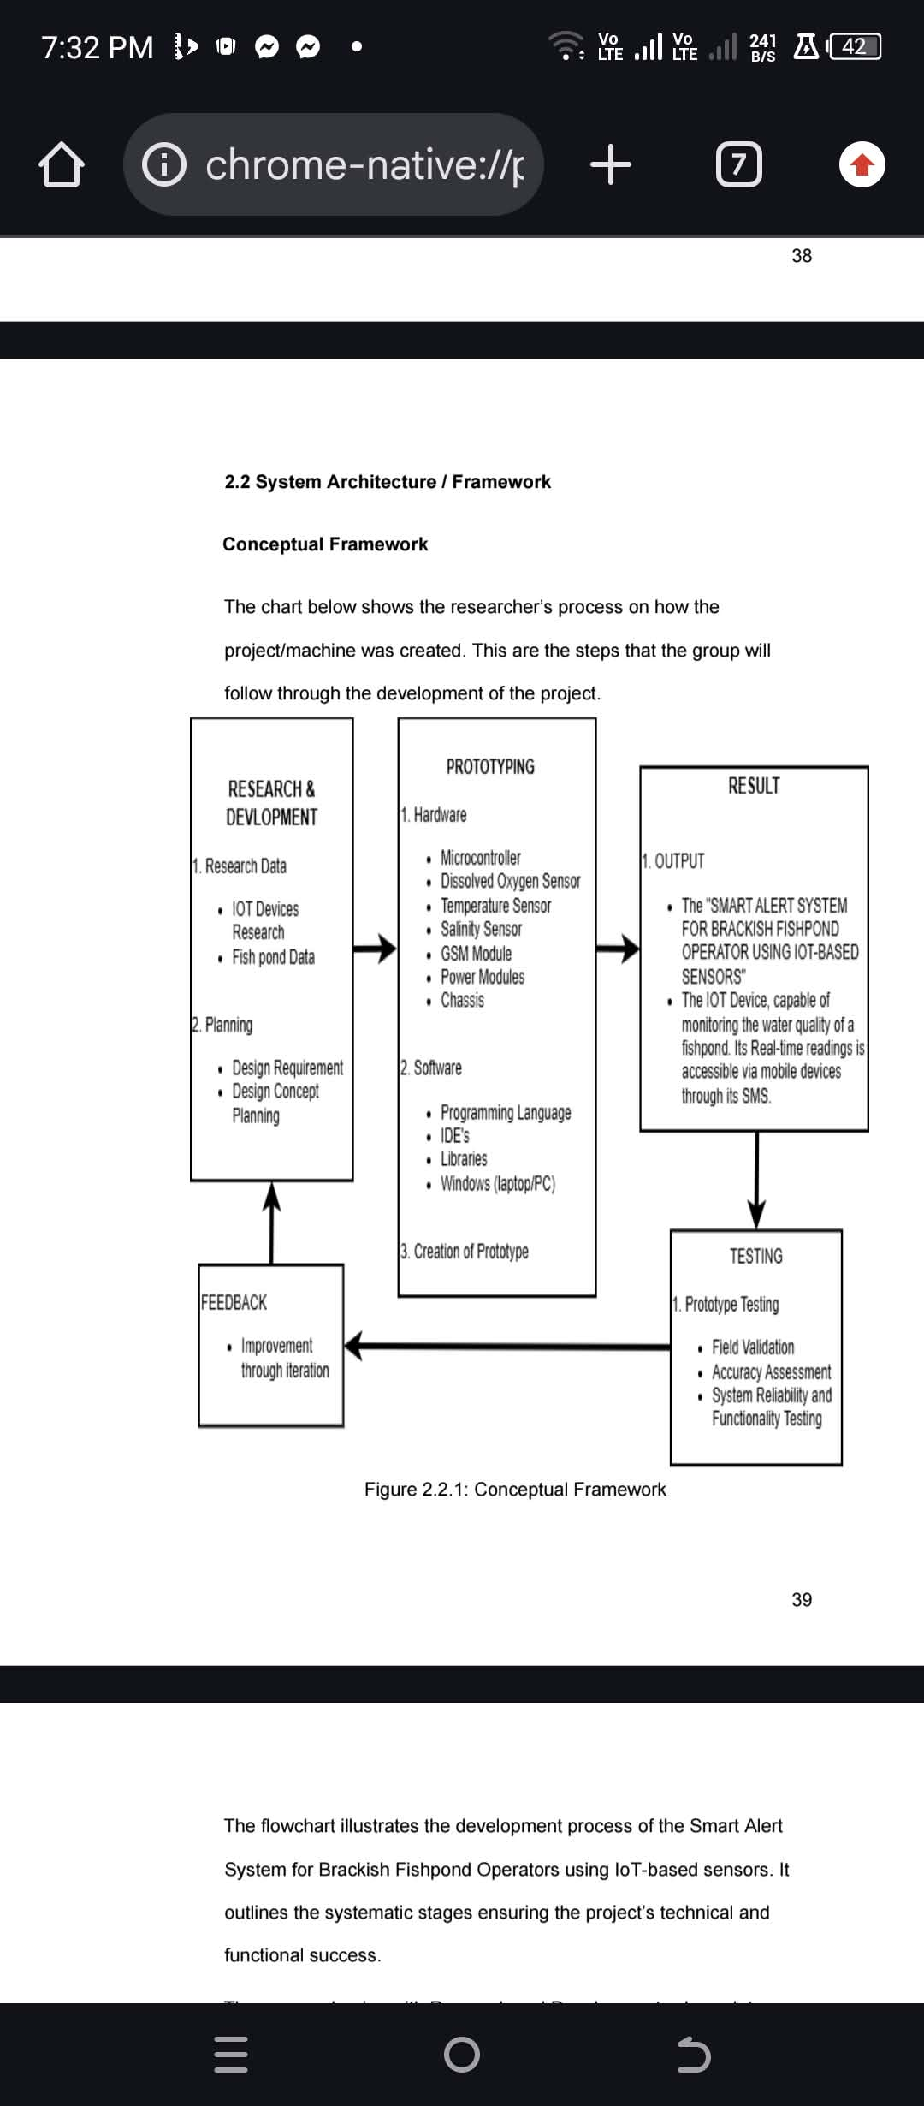
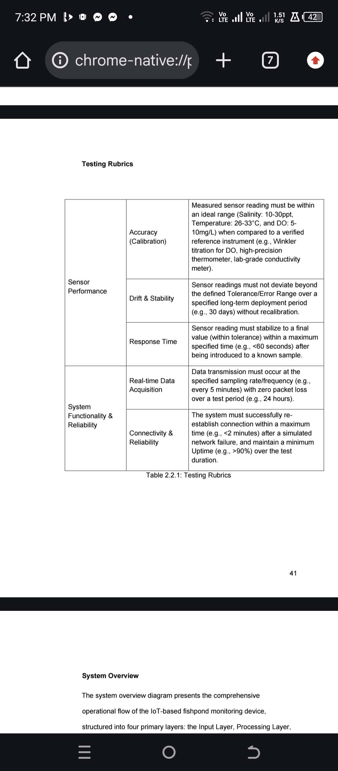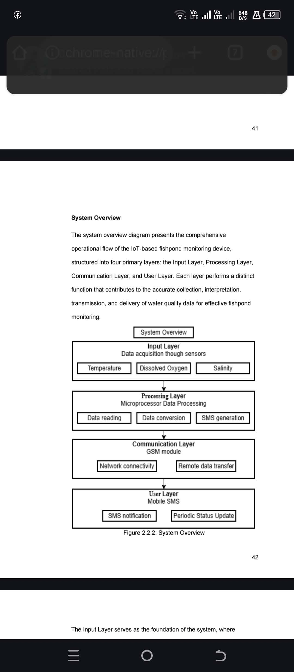
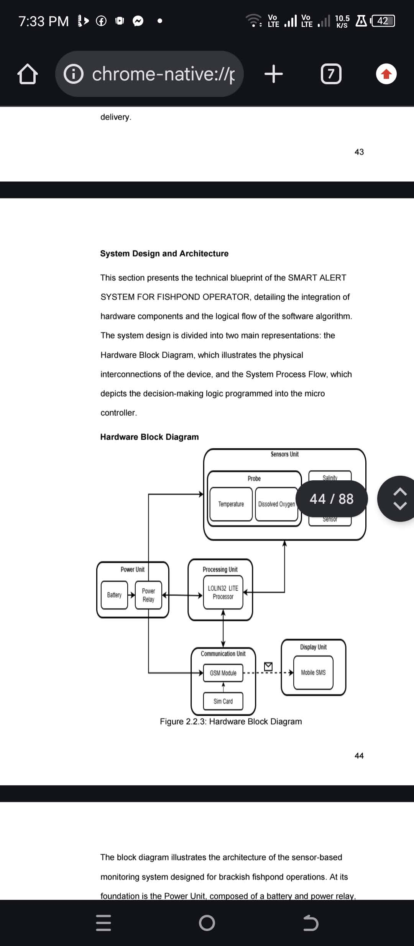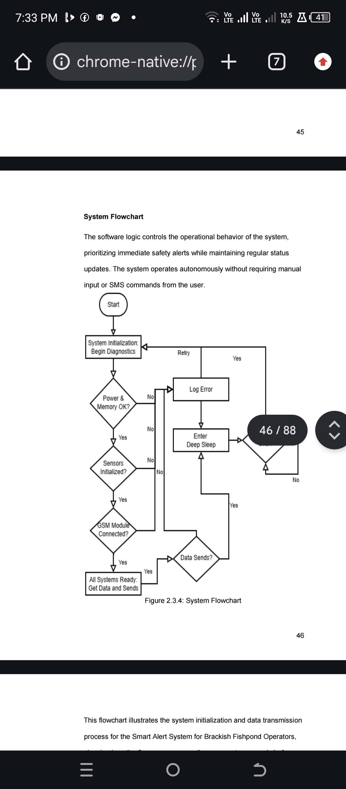

- 2.4 Software and Tools Used
Gagawin mo dito ay hardware (kasama body dito) and software (back-end and front-end.) Dapat complete daw sabi ni ate sai
Ito ang Example:
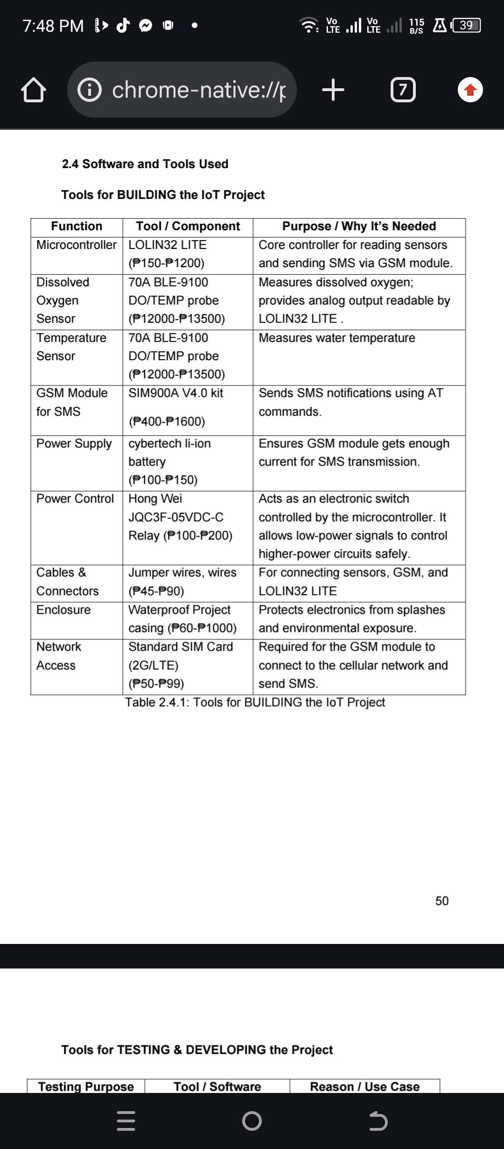
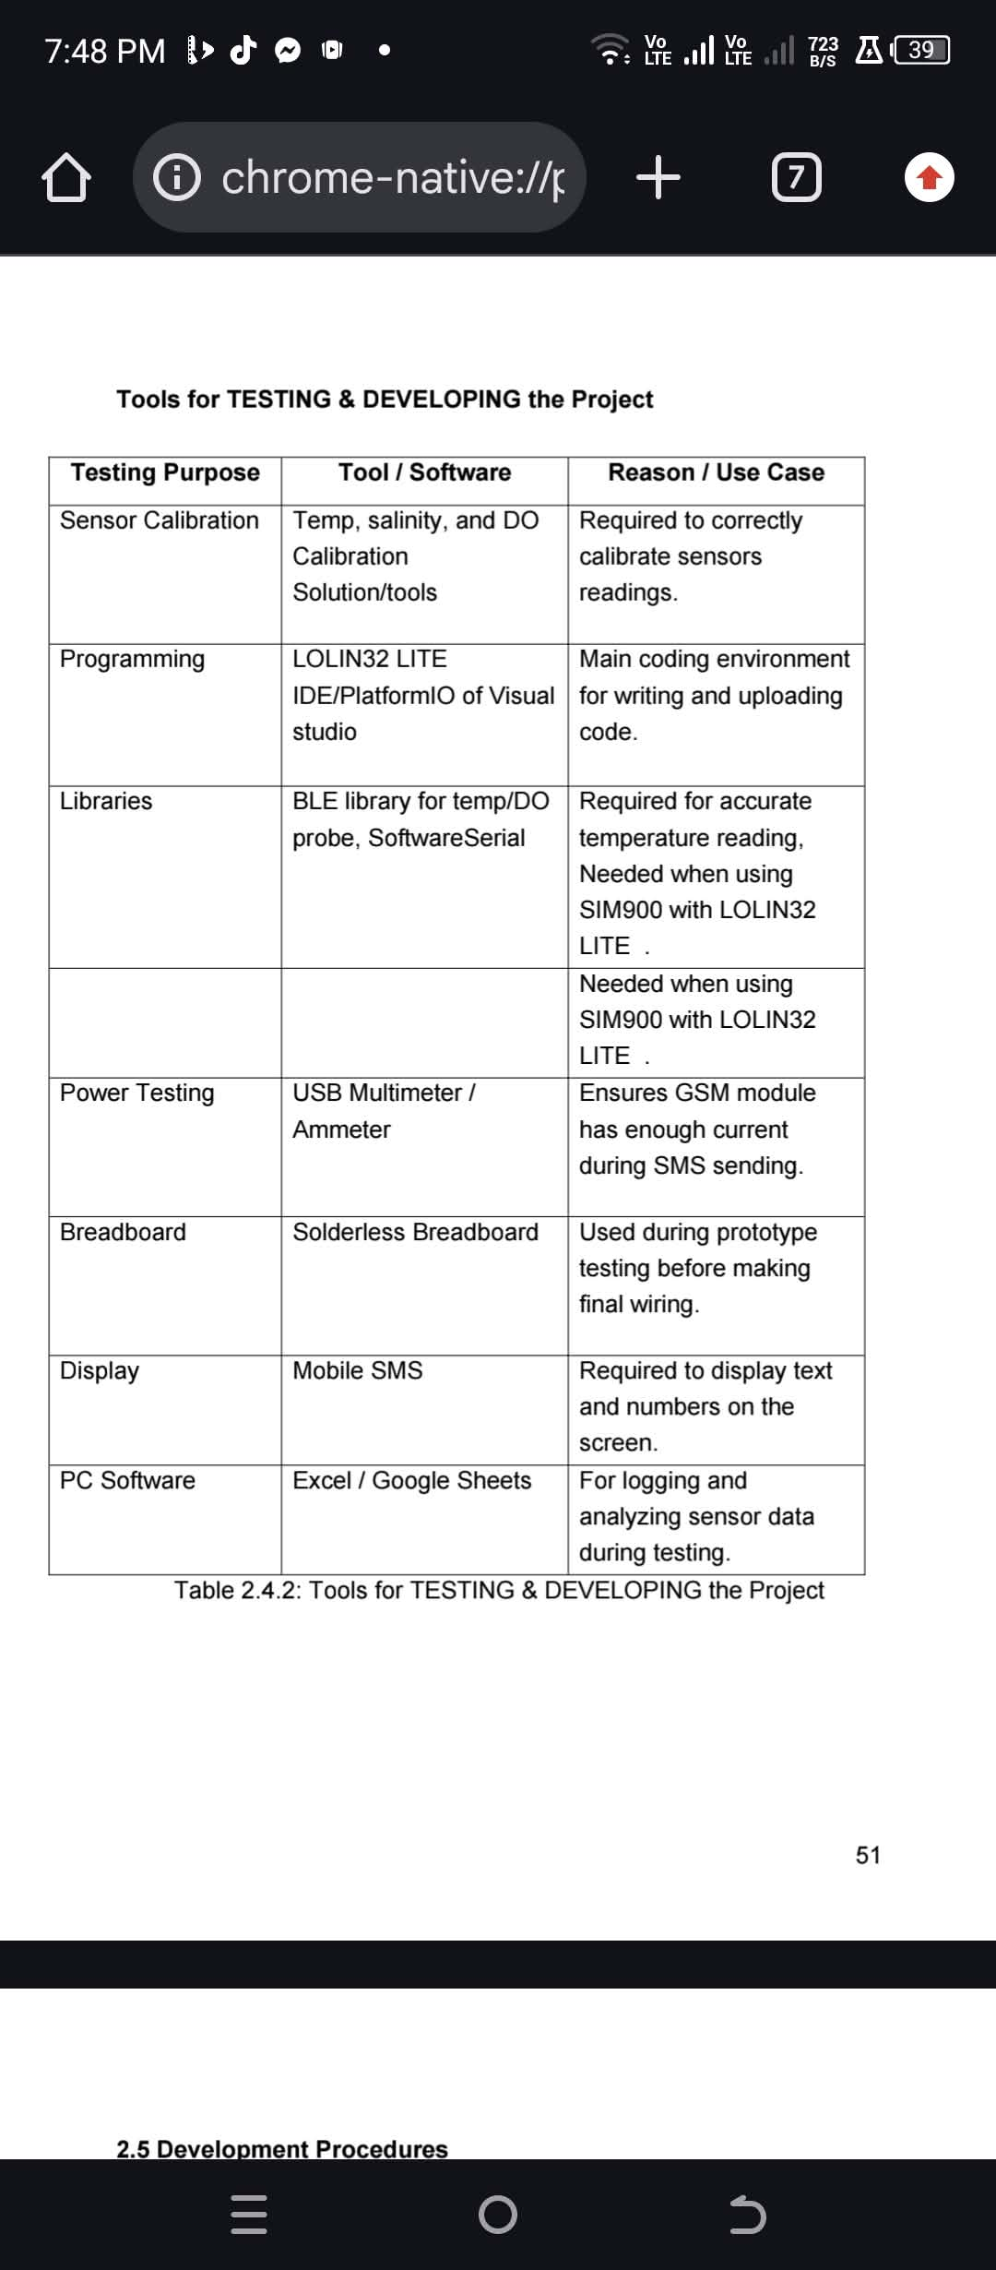
- 2.5 Development Procedures
Gawin mo dito kung ano yung mga procedures, and ito Pressure Data Processing Flowchart, AI Prediction Model Workflow
Ito example:
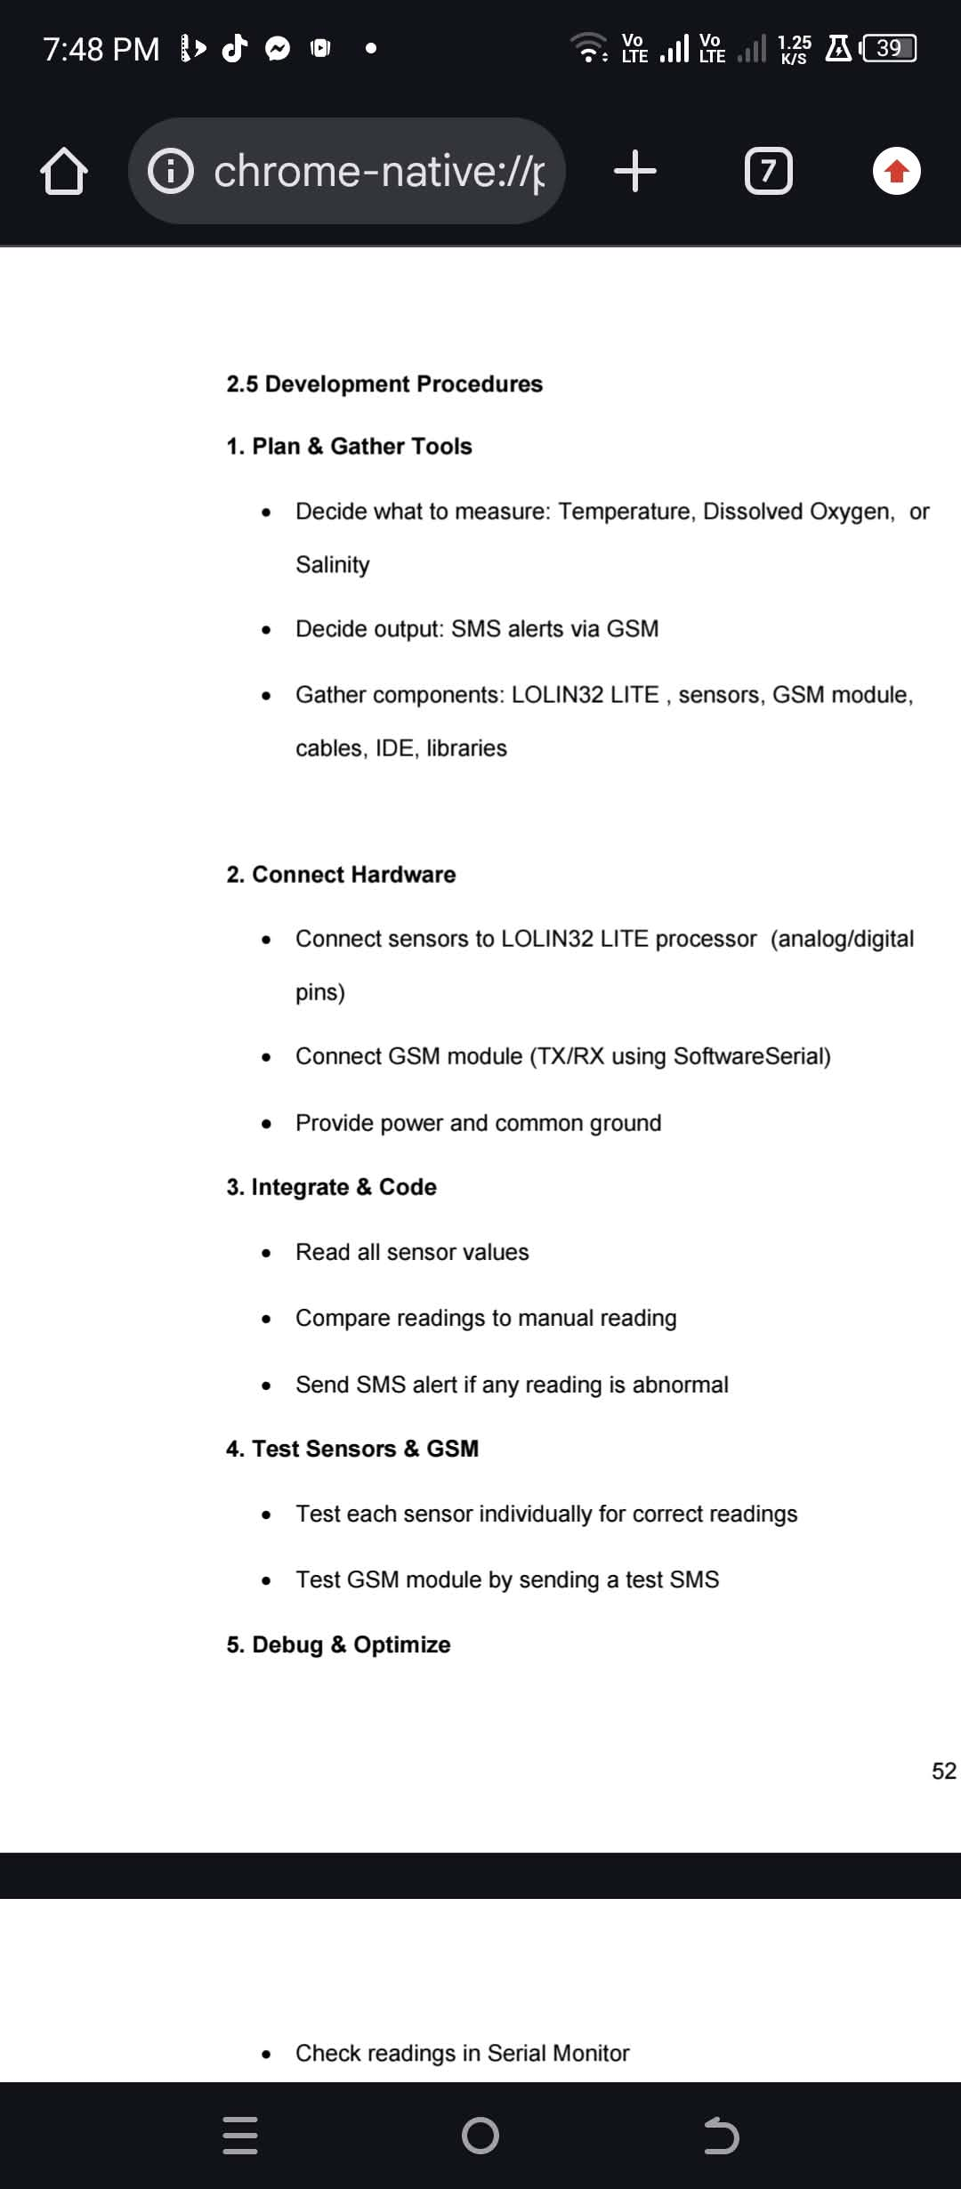
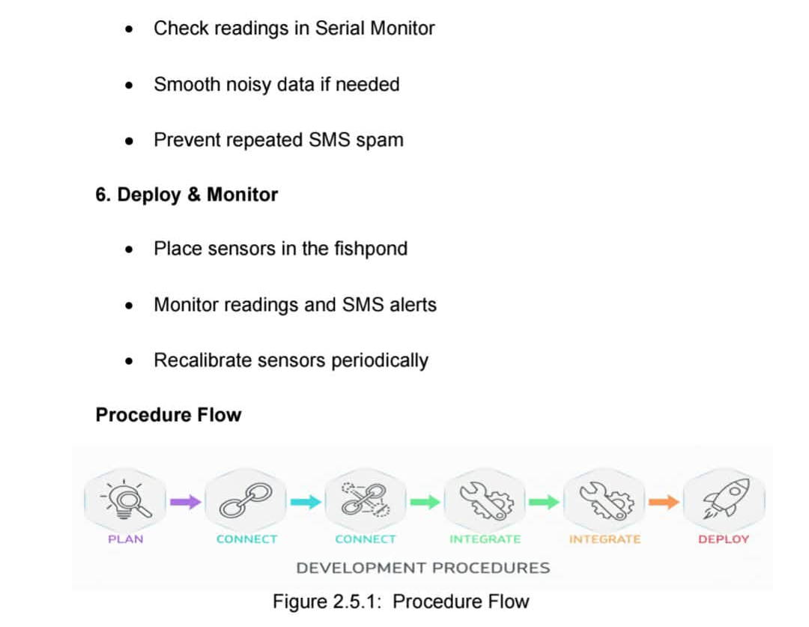
- 2.6 Testing and Evaluation
Gawan mo to kung ano yung pwede mo gamitin na testing, then gawan mo ng evaluation (may formula ata ito). Proposed testing methods, Evaluation metrics
- Testing and Validation Workflow
- Testing Methods
- Evaluation Criteria / Testing Rubrics

